PRACTICALS
PROGRAMMING WITH C

Q. Write a C program to print “Hello World”.
CODE:

#include<stdio.h>
int main()
{
printf(“Hello World\n”);
return 0;
}

Q. Write a C program to swap two numbers.
CODE:

#include<stdio.h>
int main()
{
int a=2,b=3;
printf(“The value of a is 2 and b is 3 before swapping.\n”);
a=a+b;
b=a-b;
a=a-b;
printf(“The value of a is %d and b is %d after swapping.\n”,a,b);
return 0;
}

Q. Write a C program to swap two numbers with the use of a temporary variable.
CODE:

#include<stdio.h>
int main()
{
int a,b,c;
printf(“Enter the value of a & b :”);
scanf(“%d%d”,&a,&b);
printf(“The value of a=%d and b=%d before swapping.\n”,a,b);
c=a+b;
a=c-a;
b=c-b;
printf(“The value of a=%d and b=%d after swapping.\n”,a,b);
return 0;
}

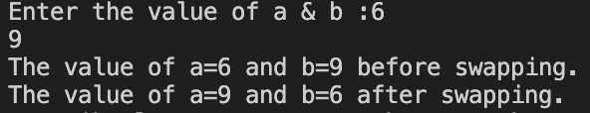

Q. Write a C program for the addition of two numbers.
CODE:

#include<stdio.h>
int main()
{
int a,b,sum;
printf(“Enter the value of a :”);
scanf(“%d”,&a);
printf(“Enter the value of b :”);
scanf(“%d”,&b);
sum=a+b;
printf(“The addition of a and b is %d\n”,sum);
return 0;
}

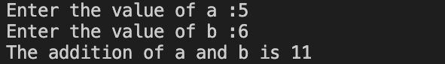

Q. Write a C program for the subtraction of two numbers.
CODE:

#include<stdio.h>
int main()
{
int a,b,sub;
printf(“Enter the value of a :”);
scanf(“%d”,&a);
printf(“Enter the value of b :”);
scanf(“%d”,&b);
sub=a-b;
printf(“The Subtraction of a and b is %d\n”,sub);
return 0;
}

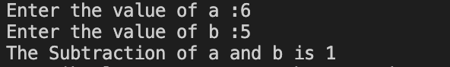

Q. Write a C program for the multiplication of two numbers.
CODE:

#include<stdio.h>
int main()
{
int a,b,mul;
printf(“Enter the value of a :”);
scanf(“%d”,&a);
printf(“Enter the value of b :”);
scanf(“%d”,&b);
mul=a*b;
printf(“The Multiplication of a and b is %d\n”,mul);
return 0;
}

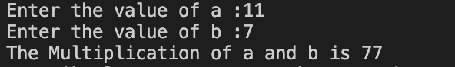

Q. Write a C program for the division of two numbers.
CODE:

#include<stdio.h>
int main()
{
int a,b,div;
printf(“Enter the value of a :”);
scanf(“%d”,&a);
printf(“Enter the value of b :”);
scanf(“%d”,&b);
div=a/b;
printf(“The Division of a and b is %d\n”,div);
return 0;
}

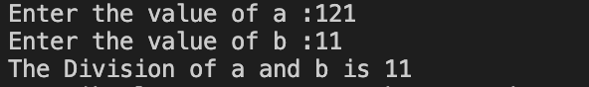

Q. Write a C program to do all the arithmetic functions (addition, subtraction, multiplication and division) at once in one equation for five numbers.
CODE:

#include<stdio.h>
int main()
{
float a,b,c,d,e,f;
printf(“Enter the value of a :”);
scanf(“%f”,&a);
printf(“Enter the value of b :”);
scanf(“%f”,&b);
printf(“Enter the value of c :”);
scanf(“%f”,&c);
printf(“Enter the value of d :”);
scanf(“%f”,&d);
printf(“Enter the value of e :”);
scanf(“%f”,&e);
f=((a+b-c)*d)/e;
printf(“The value of f=(a+b-c)*d)/e is %f\n”,f);
return 0;
}

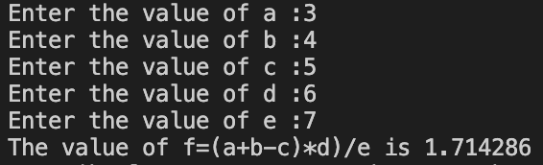

Q. Write a C program to find the area of a circle.
CODE:

#include<stdio.h>
#define PI 3.14
int main()
{
float r,a;
printf(“Enter the value of radius for a circle :”);
scanf(“%f”,&r);
a=PI*r*r;
printf(“The Area of the Circle is %f\n ”,a);
return 0;
}

Q. Write a C program to find the circumference of a circle.
CODE:

#include<stdio.h>
#define PI 3.14
int main()
{
float r,c;
printf(“Enter the value of radius for a circle :”);
scanf(“%f”,&r);
c=2*PI*r;
printf(“The Circumference of the Circle is %f\n ”,c);
return 0;
}

Q. Write a C program to find the area of a triangle.
CODE:

#include<stdio.h>
int main()
{
float b,h,a;
printf(“Enter the value of base for a triangle :”);
scanf(“%f”,&b);
printf(“Enter the value of height for a triangle :”);
scanf(“%f”,&h);
a=0.5*b*h;
printf(“The Area of the Triangle is %f\n ”,a);
return 0;
}

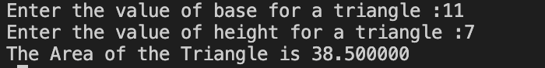

Q. Write a C program to find out the distance traveled by the equation d=ut+1/2at².
CODE:

#include<stdio.h>
int main()
{
float u,t,a,d;
printf(“Enter the value of u :”);
scanf(“%f”,&u);
printf(“Enter the value of t :”);
scanf(“%f”,&t);
printf(“Enter the value of a :”);
scanf(“%f”,&a);
d=(u*t)+(0.5*a*t*t);
printf(“The value of distance traveled is %f\n”,d);
return 0;
}

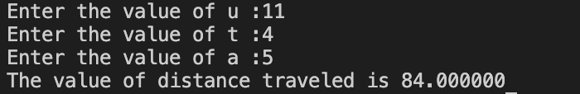

Q. Write a C program to calculate Simple interest(I)=(PRN/100); where P=Principal Amount, R=Rate of Interest, N=No. of Years.
CODE:

#include<stdio.h>
int main()
{
float I,P,R,N;
printf(“Enter the principal amount:”);
scanf(“%f”,&P);
printf(“Enter the rate of interest:”);
scanf(“%f”,&R);
printf(“Enter the time:”);
scanf(“%f”,&N);
I=(P*R*N)/100;
printf(“The Simple Interest form the given data is %f”,I);
return 0;
}

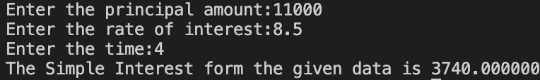

Q. Write a C program to find the ASCII value of a character.
CODE:

#include<stdio.h>
int main()
{
char c;
printf(“Enter the Character: ”);
scanf(“%c”,&c);
printf(“The ASCII value of %c is %d\n”,c,c);
return 0;
}



Q. Write a C program that scans an integer from the user and checks whether it is divisible by 3 or not.
CODE:
#include<stdio.h>
int main()
{
int num;
printf("Enter a number: ");
scanf("%d",&num);
if(num%3==0)
{
printf("The entered number is divisible by 3\n");
}
else
{
printf("The entered number is not divisible by 3\n");
}
return 0;
}

Q. Write a C program to read marks of a student and find whether a student is pass or fail.
CODE:

#include<stdio.h>
int main()
{
int marks;
printf("Enter your marks: ");
scanf("%d",&marks);
if(marks>=33)
{
printf("PASS\n");
}
else
{
printf("FAIL\n");
}
return 0;
}

Q. Write a C program to check whether a person is eligible for voting or not.
CODE:

#include<stdio.h>
int main()
{
int age;
printf("Enter your age: ");
scanf("%d",&age);
age>=18 ? printf("YOU CAN VOTE\n") : printf("YOU CANNOT VOTE\n");
return 0;
}

Q. Write a C program that read marks of a student and your program should display an equivalent grade according to the following table:
MARKS GRADE
100-80 DISTINCTION
79-60 FIRST CLASS
59-40 SECOND CLASS
<40 FAIL
CODE:

#include<stdio.h>
int main()
{
int marks;
printf("Enter your marks(0-100): ");
scanf("%d",&marks);
if(100>=marks && marks>=80)
{
printf("YOU ARE PASSED WITH DISTINCTION\n");
}
else if(79>=marks && marks>=60)
{
printf("YOU ARE PASSED WITH FIRST CLASS\n");
}
else if(59>=marks && marks>=40)
{
printf("YOU ARE PASSED WITH SECOND CLASS\n");
}
else if(40>marks)
{
printf("YOU ARE FAIL\n");
}
else
{
printf("ERROR");
}
return 0;
}

Q. Write a C program which takes the age of the user as an input and shows how many seconds he has lived.
CODE:

#include<stdio.h>
int main()
{
float age;
printf("Enter your age: ");
scanf("%f",&age);
printf("YOU LIVED %f seconds",age*86400*365);
return 0;
}

Q. Write a C program that reads numbers from 1 to 7 and print the day relatively from monday to sunday.
CODE:

#include<stdio.h>
int main()
{
int num;
printf("Enter a number(1-7) for a day in a week: ");
scanf("%d",&num);
switch (num)
{
case 1: printf("MONDAY\n");
break;
case 2: printf("TUESDAY\n");
break;
case 3: printf("WEDNESDAY\n");
break;
case 4: printf("THURSDAY\n");
break;
case 5: printf("FRIDAY\n");
break;
case 6: printf("SATURDAY\n");
break;
case 7: printf("SUNDAY\n");
break;
default: printf("ERROR\n");
break;
}

return 0;
}

Q. Write a C program to check whether the entered number is Capital or small or digit.
CODE:

#include<stdio.h>
int main()
{
char ch;
printf("Enter a character or a digit: ");
scanf("%c",&ch);
if(ch>=0 || ch<=0)
{
printf("THE ENTERED NUMBER IS A DIGIT.\n");
}
else if(ch>= 'a' && ch<= 'z')
{
printf("THE ENTERED NUMBER IS A LOWERCASE ALPHABET.\n");
}
else if(ch>= 'A' && ch<= 'Z')
{
printf("THE ENTERED NUMBER IS A UPPERCASE ALPHABET.\n");
}
else if(ch== '*' || ch== '$' || ch== '#' || ch== '@')
{
printf("THE ENTERED NUMBER IS A SPECIAL CHARACTER.\n");
}
else
{
printf("ERROR\n");

}
return 0;
}

Q. Write a C program to find the accepted number is positive or negative or zero.
CODE:

#include<stdio.h>
int main()
{
int num;
printf("Enter a number: ");
scanf("%d",&num);
if(num>0)
{
printf("POSITIVE\n");
}
else if(num<0)
{
printf("NEGATIVE\n");
}
else
{
printf("ZERO\n");
}
return 0;
}

Q. Write a C program to enter a distance in kilometers and convert it into meters, feets, inches and centimeters.
CODE:

#include<stdio.h>
int main()
{
float distance,m,cm,ft,in;
printf("Enter the distance(in km): ");
scanf("%f",&distance);
m=distance*1000;
ft=distance*3280.84;
in=distance*39370.10;
cm=distance*100000;
printf("METERS: %.2f m\n",m);
printf("INCHES: %.2f in\n",in);
printf("FEETS: %.2f ft\n",ft);
printf("CENTI-METERS: %.2f cm\n",cm);
return 0;
}

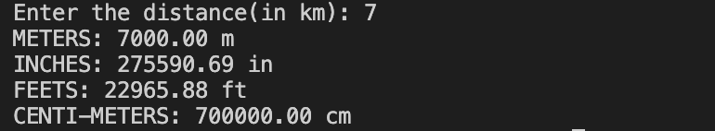

Q. Write a C program to take the temperature from the user in fahrenheit and display the temperature in celsius.
CODE:

#include<stdio.h>
int main()
{
float f,c;
printf("Enter the temperature(in fahrenheit): ");
scanf("%f",&f);
c=(f-32)*5/9;
printf("The temperature in celsius is %.2f\n",c);
return 0;
}

Q. Write a C program to calculate profit and loss.
CODE:

#include<stdio.h>
int main()
{
int p,l,sp,cp;
printf("Enter the cost price: ");
scanf("%d",&cp);
printf("Enter the selling price: ");
scanf("%d",&sp);
if(sp>cp)
{
printf("PROFIT BY %d\n",sp-cp);
}
else if(cp>sp)
{
printf("LOSS BY %d\n",cp-sp);
}
else
{
printf("NO PROFIT NO LOSS\n");
}
return 0;
}

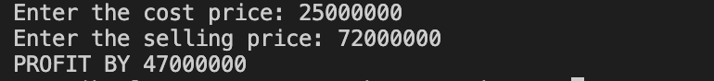

Q. Write a C program to input the amount of money from the user and print the amount of notes (2000,500,200,100,50,20,10,5,2,1) for the amount.
CODE:

#include<stdio.h>
int main()
{
int amount,n2000,n500,n200,n100,n50,n20,n10,n5,n2,n1;
n2000=n500=n200=n100=n50=n20=n10=n5=n2=n1=0;
printf("Enter the amount of money: ");
scanf("%d",&amount);
if(amount>=2000)
{
n2000=amount/2000;
amount-=n2000*2000;
printf("2000 NOTES: %d\n",n2000);
}
if(amount>=500)
{
n500=amount/500;
amount-=n500*500;
printf("500 NOTES: %d\n",n500);
}
if(amount>=200)
{
n200=amount/200;
amount-=n200*200;
printf("200 NOTES: %d\n",n200);
}
if(amount>=100)
{
n100=amount/100;
amount-=n100*100;
printf("100 NOTES: %d\n",n100);
}
if(amount>=50)
{
n50=amount/50;
amount-=n50*50;
printf("50 NOTES: %d\n",n50);
}
if(amount>=20)
{
n20=amount/20;
amount-=n20*20;
printf("20 NOTES: %d\n",n20);
}
if(amount>=10)
{
n10=amount/10;
amount-=n10*10;
printf("10 NOTES: %d\n",n10);
}
if(amount>=5)
{
n5=amount/5;
amount-=n5*5;
printf("5 NOTES: %d\n",n5);
}
if(amount>=2)
{
n2=amount/2;
amount-=n2*2;
printf("2 NOTES: %d\n",n2);
}
if(amount>=1)
{
n1=amount;
printf("1 NOTES: %d\n",n1);
}
// printf("2000 NOTES: %d\n",n2000);
// printf("500 NOTES: %d\n",n500);
// printf("200 NOTES: %d\n",n200);
// printf("100 NOTES: %d\n",n100);
// printf("50 NOTES: %d\n",n50);
// printf("20 NOTES: %d\n",n20);
// printf("10 NOTES: %d\n",n10);
// printf("5 NOTES: %d\n",n5);
// printf("2 NOTES: %d\n",n2);
// printf("1 NOTES: %d\n",n1);
}

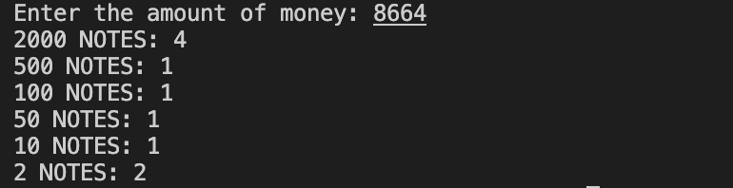

Q. Write a program to perform Addition, Subtraction, Multiplication and Division of 2
numbers as per user’s choice (using if…else/Nested if/Ladder if).
CODE:
#include<stdio.h>
int main()
{
char ch;
int a,b;
printf("Enter the operation: ");
scanf("%c",&ch);
printf("Enter two numbers: ");
scanf("%d%d",&a,&b);
if(ch=='+')
{
printf("%d",a+b);
}
if(ch=='-')
{
printf("%d",a-b);
}
if(ch=='*')
{
printf("%d",a*b);
}
if(ch=='/')
{
printf("%d",a/b);
}
return 0;
}

Q. Write a C program that reads 5 numbers and sum of all odd values between them.
CODE:
#include<stdio.h>
int main()
{
int i,n[5],sum=0;
for(i=0;i<5;i++)
{
printf("Enter element %d: ",i+1);
scanf("%d",&n[i]);
}
for(i=0;i<5;i++)
{
if(n[i]%2!=0)
{
sum+=n[i];
}
}
printf("%d\n",sum);
return 0;
}

Q. Write a program to find the sum of the first N odd numbers. Ex. 1+3+5+7+………..+N
#include <stdio.h>
int main()
{
int n, i, sum=0;
printf("Enter the value of n: ");
scanf("%d",&n);
for(i=1; i<=n; i++)
{
if(i%2 != 0)
{
if(i == n)
{
printf("%d",i);
}
else
{
printf("%d + ",i);
}
sum = sum + i;
}
}
printf("\nSum of first %d odd numbers is %d\n",n , sum);
return 0;
}

Q. Write a C program to reverse the given number.
CODE:
​​#include<stdio.h>
int main()
{
int n,i=1;
printf("Enter a number: ");
scanf("%d",&n);
printf("The reverse of number is ");
do
{
printf("%d",n%10);
n/=10;
}while(n!=0);
printf("\n");
return 0;
}

Q. Write a C program to display the cube of the number up to a given integer.
CODE:
#include<stdio.h>
int main()
{
int i,n;
printf("Enter a number: ");
scanf("%d",&n);
for(i=1;i<=n;i++)
{
printf("The cube of %d is %d\n",i,i*i*i);
}
return 0;
}

Q. Write a C program to print a multiplication table with the use of a for loop.
CODE:
#include<stdio.h>
int main()
{
int n,i;
printf("Enter a number: ");
scanf("%d",&n);
for(i=1;i<=12;i++)
{
printf("%d x %d = %d\n",n,i,n*i);
}
return 0;
}

Q. Write a C program to print:
1
1 2
1 2 3
1 2 3 4
1 2 3 4 5
CODE:
#include<stdio.h>
int main()
{
int i,j;
for(i=1;i<=5;i++)
{
for(j=1;j<=i;j++)
{
printf("%d",j);
}
printf("\n");
}
return 0;
}

Q. Write a C program to print:
1
12
123
1234
12345
CODE:
#include<stdio.h>
int main()
{
int i,j,k;
for(i=1;i<=5;i++)
{
for(k=i;k<5;k++)
{
printf(" ");
}
for(j=1;j<=i;j++)
{
printf("%d",j);
}
printf("\n");
}
return 0;
}

Q. Write a C program to print:
1 2 3 4 5
1 2 3 4
1 2 3
1 2
1
CODE:
#include<stdio.h>
int main()
{
int i,j;
for(i=5;i>=1;i--)
{
for(j=1;j<=i;j++)
{
printf("%d",j);
}
printf("\n");
}
return 0;
}

Q. Write a C program to print:
5 4 3 2 1
5 4 3 2
5 4 3
5 4
5
CODE:
#include<stdio.h>
int main()
{
int i,j;
for(i=1;i<=5;i++)
{
for(j=5;j>=i;j--)
{
printf("%d",j);
}
printf("\n");
}
return 0;
}

Q. Write a C program to print:
5 5 5 5 5
4 4 4 4
3 3 3
2 2
1
CODE:
#include<stdio.h>
int main()
{
int i,j;
for(i=5;i>=1;i--)
{
for(j=1;j<=i;j++)
{
printf("%d",i);
}
printf("\n");
}
return 0;
}

Q. Write a C program to print:
1
2 2
3 3 3
4 4 4 4
5 5 5 5 5
CODE:
#include<stdio.h>
int main()
{
int i,j;
for(i=1;i<=5;i++)
{
for(j=1;j<=i;j++)
{
printf("%d",i);
}
printf("\n");
}
return 0;
}

Q. Write a C program to print:
A
A B
A B C
A B C D
A B C D E
CODE:
#include<stdio.h>
int main()
{
char i,j;
for(i='A';i<='E';i++)
{
for(j='A';j<=i;j++)
{
printf("%c",j);
}
printf("\n");
}
return 0;
}

Q. Write a C program to print:
A
B B
C C C
D D D D
E E E E E
CODE:
#include<stdio.h>
int main()
{
char i,j;
for(i='A';i<='E';i++)
{
for(j='A';j<=i;j++)
{
printf("%c",j);
}
printf("\n");
}
return 0;
}

Q. Write a C program to print:
A B C D E
A B C D
A B C
A B
A
CODE:
#include<stdio.h>
int main()
{
char i,j;
for(i='E';i>='A';i--)
{
for(j='A';j<=i;j++)
{
printf("%c",j);
}
printf("\n");
}
return 0;
}

Q. Write a C program to print:
E E E E E
D D D D
C C C
B B
A
CODE:
#include<stdio.h>
int main()
{
char i,j;
for(i='E';i>='A';i--)
{
for(j='A';j<=i;j++)
{
printf("%c",i);
}
printf("\n");
}
return 0;
}

Q. Write a C program to print:
1
1 0
1 0 1
1 0 1 0
1 0 1 0 1
CODE:
#include<stdio.h>
int main()
{
int i,j;
for(i=1;i<=5;i++)
{
for(j=1;j<=i;j++)
{
printf("%d",j%2);
}
printf("\n");
}
return 0;
}

Q. Write a C program to print:
*
* *
* * *
* * * *
* * * * *
CODE:
#include<stdio.h>
int main()
{
int i,j,s;
for(i=1;i<=5;i++)
{
for(s=i;s<5;s++)
{
printf(" ");
}
for(j=1;j<=i;j++)
{
printf(" *");
}
printf("\n");
}
return 0;
}

Q. Write a C program to print:
* * * * *
* * * *
* * *
* *
*
CODE:
#include<stdio.h>
int main()
{
int i,j,s;
for(i=5;i>=1;i--)
{
for(s=i;s<5;s++)
{
printf(" ");
}
for(j=1;j<=i;j++)
{
printf(" *");
}
printf("\n");
}
return 0;
}

Q. Write a C program to print:
*
* *
* * *
* * * *
* * * * *
* * * *
* * *
* *
*
CODE:
#include<stdio.h>
int main()
{
int i,j,s;
for(i=1;i<=5;i++)
{
for(s=i;s<5;s++)
{
printf(" ");
}
for(j=1;j<=i;j++)
{
printf(" *");
}
printf("\n");
}
for(i=4;i>=1;i--)
{
for(s=i;s<5;s++)
{
printf(" ");
}
for(j=1;j<=i;j++)
{
printf(" *");
}
printf("\n");
}
return 0;
}

Q. Write a C program to multiply a 3x3 matrix.
CODE:
#include<stdio.h>
int main()
{
int a[3][3]={{1,1,1},{2,2,2},{3,3,3}};
int b[3][3]={{1,1,1},{2,2,2},{3,3,3}};
int res[3][3];
for(int i=0;i<3;i++)
{
for(int j=0;j<3;j++)
{
res[i][j]=0;
{
for(int k=0;k<3;k++)
{
res[i][j]+=a[i][k]*b[k][j];
}
}
}
}
printf("The product of the two matrix is: \n");
for(int i=0;i<3;i++)
{
for(int j=0;j<3;j++)
{
printf("%d\t",res[i][j]);
}
printf("\n");
}
return 0;
}

Q. Write a C program to add two matrices.
CODE:
#include<stdio.h>
int main()
{
int a[3][3]={{1,1,1},{2,2,2},{3,3,3}};
int b[3][3]={{1,1,1},{2,2,2},{3,3,3}};
int res[3][3];
for(int i=0;i<3;i++)
{
for(int j=0;j<3;j++)
{
res[i][j]=0;
res[i][j]=a[i][j]+b[i][j];
}
}
printf("The addition of the two matrix is: \n");
for(int i=0;i<3;i++)
{
for(int j=0;j<3;j++)
{
printf("%d\t",res[i][j]);
}
printf("\n");
}
return 0;
}

Q. Write a C program to calculate the square of the number using library functions.
CODE:
#include<stdio.h>
#include<math.h>
int main()
{
int n;
printf("Enter a number: ");
scanf("%d",&n);
printf("The square of %d is %.2f\n",n,pow(n,2));
return 0;
}

Q. Write a C program to add two numbers using a function
CODE:
#include<stdio.h>
int add(int,int);
int main()
{
add(5,11);
}
int add(int a,int b)
{
printf("First number: %d\nSecond number: %d\n",a,b);
printf("The sum of given two number is %d\n",a+b);
return 0;
}

Q. Write a C program to swap two numbers using a function.
CODE:
#include<stdio.h>
int swap();
int main()
{
swap();
}
int swap()
{
int a,b;
//int temp;
printf("Enter two numbers: ");
scanf("%d%d",&a,&b);
printf("Before swapping\nFirst number: %d and Second number: %d\n",a,b);
a=a+b;
b=a-b;
a=a-b;
//temp=a;
//a=b;
//b=temp;
printf("After swapping\nFirst number: %d and Second number: %d\n",a,b);
return 0;
}

Q. Write a C program to check whether the number is prime or not using a function.
CODE:
#include<stdio.h>
int prm();
int main()
{
prm();
}
int prm()
{
int i,n,count=0;
printf("Enter a number: ");
scanf("%d",&n);
for(i=1;i<=n;i++)
{
if(n%i==0)
{
count++;
}
}
if(count==2)
{
printf("Number is Prime\n");
}
else
{
printf("Number is Not Prime\n");
}
return 0;
}

Q. Write a C program to give detail about 5 students using structure.
CODE:
#include<stdio.h>
struct student
{
char name[5];
int rollno;
int phone;
}s[5];
int main()
{
int i;
printf("Enter the details of 5 students.\n");
for(i=0;i<5;i++)
{
printf(">>Enter details of student %d\n",i+1);
printf("\tEnter the name: ");
scanf("%s",s[i].name);
printf("\tEnter the roll number: ");
scanf("%d",&s[i].rollno);
printf("\tEnter the phone number: ");
scanf("%d",&s[i].phone);
}
printf("\n");
for(i=0;i<5;i++)
{
printf(">>Details for Student %d\n",i+1);
printf("\tName: %s\n",s[i].name);
printf("\tRoll Number: %d\n",s[i].rollno);
printf("\tPhone Number: %d\n",s[i].phone);
}
return 0;
}

#include <stdio.h>
void main()
{

int num,r,c;
static int i=1;
static char ch='A';
printf("Enter the numbers of rows= ");
scanf("%d",&num);
for(r=1;r<=num;r++)
{
for(c=1;c<=r;c++)
{
if(r%2==0)
printf("%c",ch++);
else

printf("%d",i++);
}
printf("\n");
}

